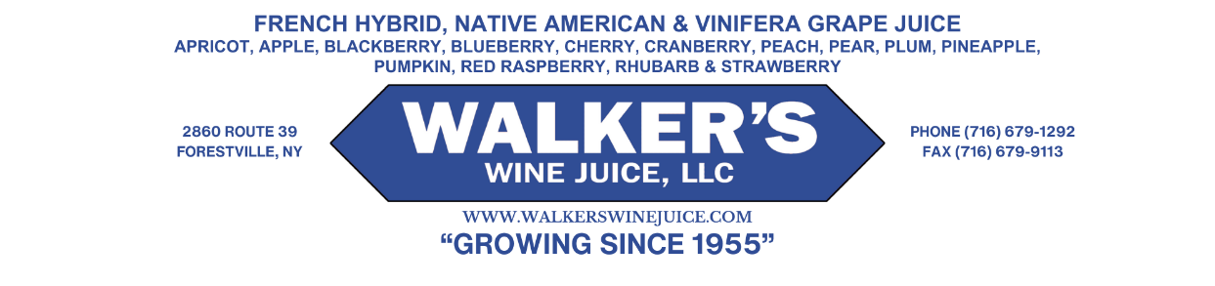
April 4th, 2025
URGENT PUMPKIN JUICE RECALL
Dear Customer:
Walker’s Wine Juice is voluntarily recalling pumpkin juice due to insufficient processing against Clostridium Botulinum. The product is packaged in 2.5 gallon bag in box and 5 gallon hedpak containers. All lots purchased prior to January 1st 2025 are subject to this recall. A typical label can be viewed below.
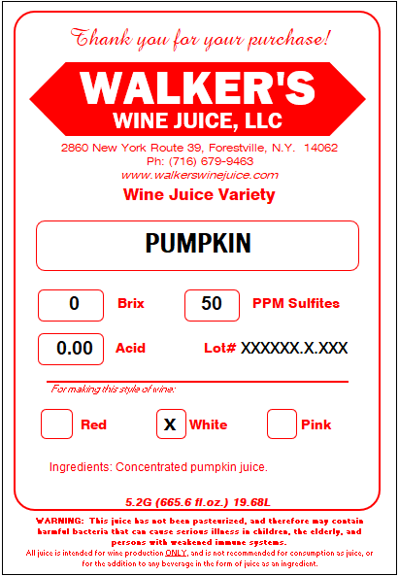
Our records show that you purchased Pumpkin juice on or before 1/1/2025. Please cease consuming wine that you made from this juice. The juice and/or wine can be disposed of by you, returning the product to Walker’s is unnecessary.
To advise the NYS Department of Agriculture and Markets as well as the FDA about the effectiveness of this recall, please contact us to discuss how much of the product you were able to destroy. We can discuss a refund at that time. You may contact Walker’s Wine Juice by email at matthew@walkerswinejuice.com or by telephone at 716-679-1292 x 1016
Thank you for your cooperation in this recall.

Matthew Walker

